1)

**AIM :**

Design your class time table using table tags

**DESCRIPTION :**

* VS Code is the software that is used to write the html code.
* All HTML documents must start with a document type declaration: <!DOCTYPE html>.
* The HTML document itself begins with <html> and ends with </html>.
* The visible part of the HTML document is between <body> and </body>.
* The center tag is used to position the element to the center of the web page
* The title tag is used to specify the name of the web page.
* <table> tag creates table in html
* Table is divided into rows and each row data is called table data
* <tr> tag creates row in a table
* td holds data in the cell
* <th> refers to table header
* Split the column into two or more cells using the attribute colspan
* Split the rows into two or more cells using the attribute rowspan
* Cell padding specifies the space between the cell content and its borders.
* Cell spacing refers to the amount of space that is held between the cells in a table.
* border attribute sets the border to the table
* bgcolor to provide background color to the table
* align is used to align the content of the table inside a cell.

**PROGRAM CODE :**

<!DOCTYPE html>

<html lang="en">

<head>

<meta charset="UTF-8">

<meta http-equiv="X-UA-Compatible" content="IE=edge">

<meta name="viewport" content="width=device-width, initial-scale=1.0">

<title>Time Table</title>

</head>

<body>

<center>

<table border="2" cellpadding=10 cellspacing=5>

<tr>

<th colspan="8">CHAITANYA BHARATHI INSTITUTE OF TECHNOLOGY (A)

</th>

</tr>

<tr>

<th colspan="8">DEPARTMENT OF COMPUTER SCIENCE AND ENGINEERING

</th>

</tr>

<tr>

<th colspan="8">Online Even Semester Class Time Table for the A.Y. 2021-22

</th>

</tr>

<tr>

<td colspan="3">Class: BE-IV SEM-CSE 2

</td>

<td colspan="3">w.e.f.: w.e.f.: 31.01.2022

</td>

<td colspan="3">

Room No: C-213

</td>

</tr>

<tr bgcolor="#ABEDAC" align="center">

<th>Period</th>

<th>1</th>

<th>2</th>

<th>3</th>

<th rowspan=2>12.30-1:10</th>

<th>4</th>

<th>5</th>

<th>6</th>

</tr>

<tr bgcolor="#ABEDAC" align="center">

<th>Day</th>

<th>9:10-10:10</th>

<th>10:20-11:20</th>

<th>11:30-12:30</th>

<th>1:10-2:10</th>

<th>2:20-3:20</th>

<th>3:30-4:30</th>

</tr>

<tr align="center">

<th rowspan=3 bgcolor="#ABEDAC" align="center">MON</th>

<td colspan=2>MFDS-B1</td>

<td>DAA-B1</td>

<td rowspan=10 align="center" bgcolor="#ABEDAC">L<br>U<br>N<br>C<br>H</td>

<td>DAA-B2</td>

<td colspan=2>MFDS-B2</td>

</tr>

<tr align="center">

<td colspan=2 rowspan=2>IWT-B2</td>

<td>DBMS-B2</td>

<td>DBMS-B2</td>

<td colspan=2 rowspan=2>IWT-B1</td>

</tr>

<tr align="center">

<td>IWT-B3</td>

<td>IWT-B3</td>

</tr>

<tr align="center">

<th rowspan="3" bgcolor="#ABEDAC">TUE</th>

<td colspan="2">DAA-B2</td>

<td>DAA-B3</td>

<td>DAA-B3</td>

<td rowspan="3">CAMP</td>

<td rowspan="3">FIT INDIA</td>

</tr>

<tr align="center">

<td colspan="2">DBMS B3</td>

<td>DBMS B1</td>

<td>DBMS B1</td>

</tr>

<tr align="center">

<td colspan=2>IWT B1</td>

<td>IWT B2</td>

<td>IWT B2</td>

</tr>

<tr align="center">

<th bgcolor="#ABEDAC">WED</td>

<td>MFDS</td>

<td>IWT</td>

<td>Library</td>

<td>CAMP</td>

<td>DBMS</td>

<td>DAA</td>

</tr>

<tr align="center">

<th bgcolor="#ABEDAC">THU</th>

<td>DBMS</td>

<td>CAMP</td>

<td>IWT</td>

<td>DAA</td>

<td>MFDS</td>

<td>EEA</td>

</tr>

<tr align="center">

<th bgcolor="#ABEDAC">FRI</th>

<td>EEA</td>

<td>EEA</td>

<td>DAA</td>

<td>MFDS</td>

<td>DBMS</td>

<td>Mentoring</td>

</tr>

<tr align="center">

<th bgcolor="#ABEDAC">SAT</th>

<td colspan="3">MOOCs/Training/Internship</td>

<td></td>

<td></td>

<td></td>

</tr>

</table>

</center>

</body>

</html>

**OUTPUT :**

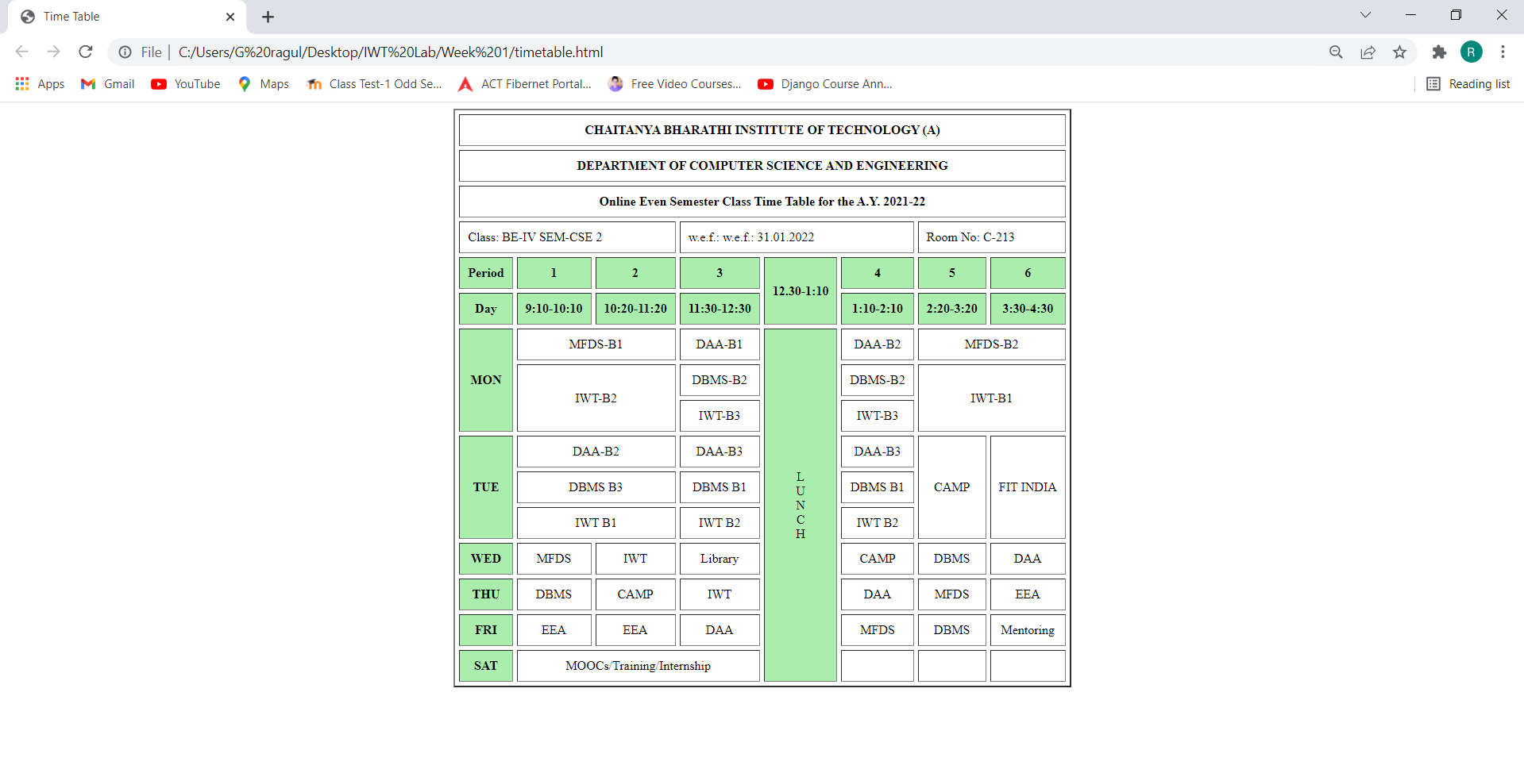

**RESULT ANALYSIS :**

We see that the column is split into two or more cells while using colspan , rows using rowspan.

Using the table tag we are able to create tables in html and using tr and td we are able to create rows and enter data respectively.

Using cellpadding and cellspacing attributes we are able to provide space.

2)

**AIM :**

Design a web page which consists of image and display your biodata

**DESCRIPTION :**

* <br> tag is used to provide a line break
* <img> tag is used to display an image in html
* src attribute is used to mention the location of the image
* <p> tag is used to enclose the data in an organized form
* <em> tag is used to emphasize the text(italic).
* <h1> defines the most important heading. <h6> defines the least important heading.

**PROGRAM CODE :**

<!DOCTYPE html>

<html lang="en">

<head>

<meta charset="UTF-8">

<meta http-equiv="X-UA-Compatible" content="IE=edge">

<meta name="viewport" content="width=device-width, initial-scale=1.0">

<title>Bio Data</title>

</head>

<body>

<br><br>

<img src="bio.png" width="300" height="300" align="left">

<br><br>

<p align="justify"><h1 align="center"><em><u>My Bio</u></em></h1><br>

<font size=4 face="Comic sans MS">I am G Ragul.<br>I have done my schooling till 10th in DAV Public School, Safilguda, Hyderabad.

<br>Then completed my inter at Narayana and currently pursuing my BTech at Chaitanya Bharathi Institute of Technolgy,Hyderabad.<br>My hobbies are playing cricket,watching movies and listening to songs and reading novels.<br>My areas of interest in the field of CS are App and Web development, Machine Learning and Software Development.</font>

</p>

</body>

</html>

**OUTPUT :**

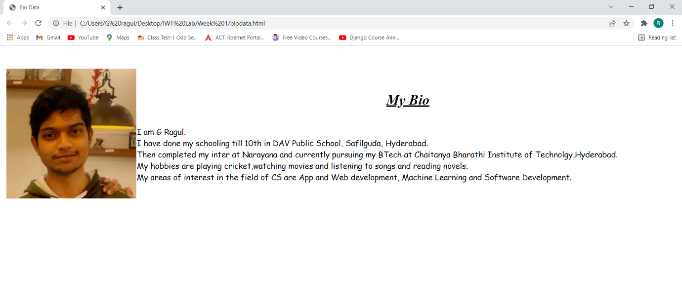

**RESULT ANALYSIS :**

Usage of img tag along with align attribute has made the image to placed towards the left.

br tag has led to white space that is clearly visible above the image.

<em> tag has made the text to be made look in italic.

3)

**AIM :**

Create Restaurant menu card sample given below or you can design your own menu card.

**DESCRIPTION :**

* <font> tag has been used to display various font style and size of the text.
* <ol> tag has been used to create ordered list.
* <ul> tag has been used to create unordered list.
* <li> tag is used to create a list item in the list
* Attributes of ul and ol is type where type for ol can be either A/a/I/i/1(default) and DISC/SQUARE/CIRCLE and start is used to define the starting number.
* <pre> tag is used to preserve space in the text.

**PROGRAM CODE :**

<!DOCTYPE html>

<html lang="en">

<head>

<meta charset="UTF-8">

<meta http-equiv="X-UA-Compatible" content="IE=edge">

<meta name="viewport" content="width=device-width, initial-scale=1.0">

<title>Menu Card</title>

</head>

<body bgcolor="#36E6CD">

<font size=5 face="Comic sans MS">

<h1><font color="red">Menu Card</font></h1>

<ol>

<li><pre>Healthy Shakes Prices</pre></li><br>

<ul>

<li><pre>Shake - 50/-</pre></li><br>

<li><pre>Badam Shake - 90/-</pre></li><br>

<li><pre>Cold Coffee - 60/-</pre></li><br><br>

</ul>

<li>Veg</li><br>

<ul>

<li><pre>Veg Biryani - 250/-</pre></li><br>

<li><pre>Pulao - 200/-</pre></li><br>

<li><pre>Panner Butter Masala - 150/-</pre></li><br><br>

</ul>

<li>Non Veg</li><br>

<ul>

<li><pre>Chicken Gravey - 300/-</pre></li><br>

<li><pre>Chicken 65 - 250/-</pre></li><br>

<li><pre>Mutton Biryani - 250/-</pre></li><br><br>

</ul>

</ol>

</font>

</body>

</html>

**OUTPUT :**

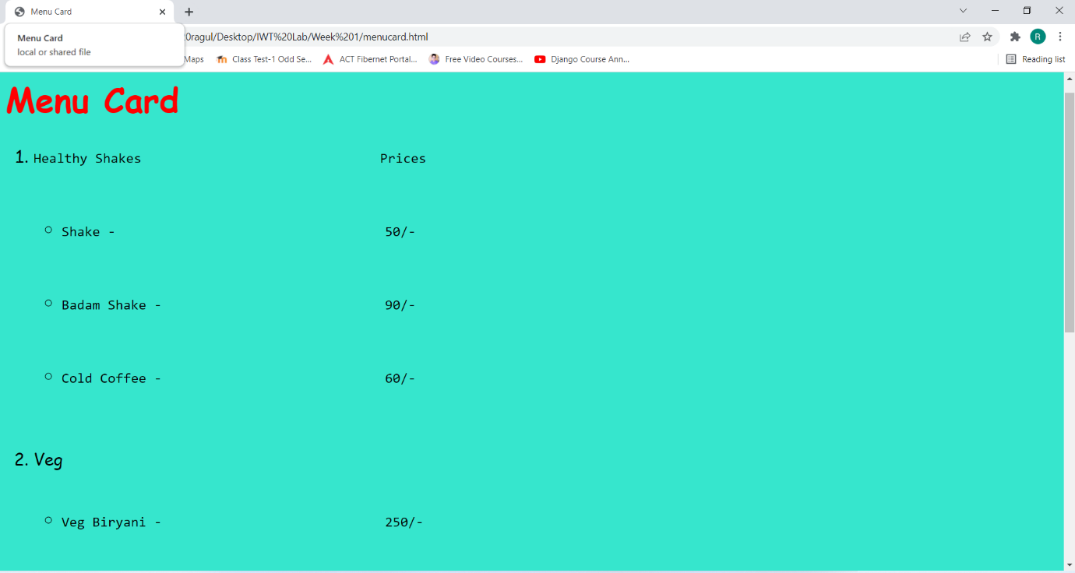

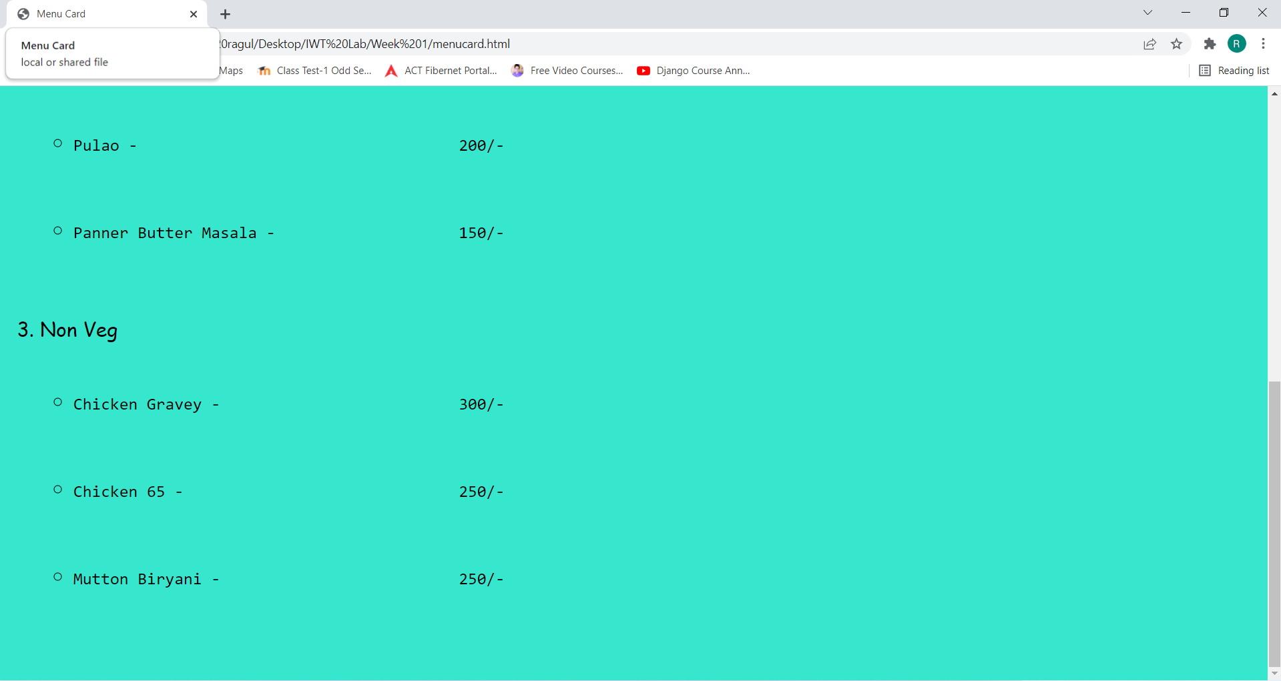

**RESULT ANALYSIS :**

Usage of attributes such as face and size along with <font> has made a difference in appearance of the text displayed which is usually different from the default look.

<pre> tag has led to preserve the space between the words and looks like how it was written in the html file.

<ul> default value from the output can be identified as disc and 1 for <ol>

4)

**AIM :**

Design a web page to images and in one column and their description in another column using table.

**DESCRIPTION :**

* <a> tag defines the hyperlink
* Hyperlink is a link that refers to a data.
* href is the most important tag for anchor tag.
* By default, links will appear as follows in all browsers, unvisited link is underlined and blue and visited link is underlined and purple.
* When href=”#TARGET” it moves to other section of the page

**PROGRAM CODE :**

<!DOCTYPE html>

<html lang="en">

<head>

<meta charset="UTF-8">

<meta http-equiv="X-UA-Compatible" content="IE=edge">

<meta name="viewport" content="width=device-width, initial-scale=1.0">

<title>Table</title>

</head>

<body>

<center><font size=5 face="Comic sans MS">

<table border="2" cellpadding="5" cellspacing="5" width=80%>

<tr align="center" bgcolor="#0FEDF6">

<th>Sno</th>

<th>Name</th>

<th>Photo</th>

<th>Profile</th>

</tr>

<tr align="center">

<td>1</td>

<td>G Ragul</td>

<td><img src="bio.png" width="100" height="100"></td>

<td><a href="biodata.html">View Here</td>

</tr>

<tr align="center">

<td>2</td>

<td>MS Dhoni</td>

<td><img src="dhoni.jpg" width="=100" height="100"></td>

<td><a href="https://en.wikipedia.org/wiki/MS_Dhoni">View Here</td>

</tr>

<tr align="center">

<td>3</td>

<td>Virat Kohli</td>

<td><img src="kohli.jpg" width="=100" height="100"></td>

<td><a href="https://en.wikipedia.org/wiki/Virat_Kohli">View Here</td>

</tr>

<tr align="center">

<td>4</td>

<td>Rohit Sharma</td>

<td><img src="rohit.jpg" width="=100" height="100"></td>

<td><a href="https://en.wikipedia.org/wiki/Rohit_Sharma">View Here</td>

</tr>

<tr align="center">

<td>5</td>

<td>Joseph Vijay</td>

<td><img src="vijay.jpg" width="=100" height="100"></td>

<td><a href="https://en.wikipedia.org/wiki/Vijay_(actor)">View Here</td>

</tr>

</table>

</font>

</center>

</body>

</html>

**OUTPUT :**

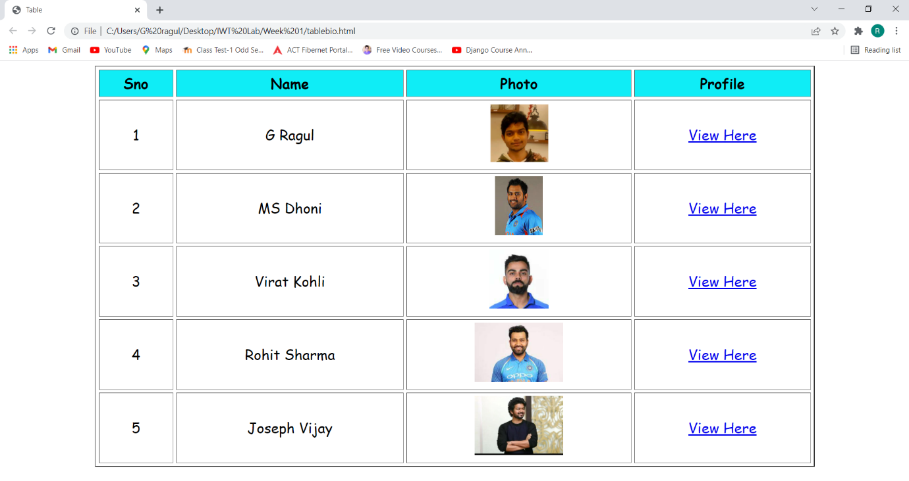

**RESULT ANALYSIS :**

Using <a> tag we are able to link to various web pages.

Usage of img tag along with align attribute has made the image to placed towards the left.

br tag has led to white space that is clearly visible above the image.

We see that the column is split into two or more cells while using colspan , rows using rowspan.

Using the table tag we are able to create tables in html and using tr and td we are able to create rows and enter data respectively.

Using cellpadding and cellspacing attributes we are able to provide space.